# **FA23: DATA VISUALIZATION: 7528**

**Visualizing Civic Engagement - City of Bloomington**

**Final Project Paper**



**Team Members:**

Krishna Teja Jillelamudi ([kjillela@iu.edu](mailto:kjillela@iu.edu))  
Venkata Sai Abhigna Devarasetty (vdevaras@iu.edu)

Fhariya Aseem Fathima ([fha@iu.edu](mailto:fha@iu.edu))

**Abstract:**

This project delves into Bloomington, Indiana's multifaceted civic engagement landscape, utilizing the comprehensive Open311 dataset. Through intricate data visualizations, the project seeks to unravel patterns, trends, and insights in civic requests and responses, thereby furnishing valuable perspectives for urban development and community engagement.

**Introduction:**

In an era where urban spaces are rapidly evolving, the dynamics of civic engagement emerge as a critical determinant of a city's vitality and responsiveness. The project "Visualizing Civic Engagement - City of Bloomington" stands at the intersection of urban studies, data science, and public administration, embodying an endeavor to decode the complex narrative of civic interaction in Bloomington, Indiana.

Even though each set of these needs has a different set of ideal response speeds, the importance of tracking them cannot be overstated. This project focuses on this aspect to provide visualizations that are informative yet understandable to everyone.

We tend to do this by using the data from the Open311 system hosted on the City of Bloomington portal. The data contains information regarding the response time to a complaint raised, the category of the complaint, and the geolocation associated with that complaint. Analyzing this treasure trove of data would help track the system's efficiency and uncover any core issues that are not apparent when looking at the complaints individually but can be seen when looking at the data.

**Motivation:**

Urban Dynamics and Citizen-Government Interactions-

The driving force behind the "Visualizing Civic Engagement - City of Bloomington" initiative stems from a profound understanding that the essence and vitality of urban centers are deeply intertwined with the interaction dynamics between residents and local governance. This interaction takes on heightened significance in the contemporary context of rapid urbanization. Bloomington, characterized by its distinctive attributes and challenges, provides a compelling framework for exploring these civic dynamics.

Urban Spaces as Ecosystems-

Central to our project is the concept of urban spaces as living ecosystems shaped and nurtured by the voices and interactions of the community. The process through which municipal authorities acknowledge and address these community voices serves as a litmus test for the city's responsiveness and dedication to its populace. We aim to highlight these crucial yet often underrepresented dialogues, showcasing the ongoing communication between Bloomington's residents and their city officials.

The Transformative Role of Data

In the modern era, the role of data in reshaping and enhancing civic participation cannot be overstated. Data-centric approaches offer transformative potential for urban administration, paving the way for more transparent governance, prompt service responses, and policies more attuned to the community's actual needs. This project taps into this potential by delving into Bloomington's Open311 data to uncover insights that can lead to more responsive governance and a more actively engaged community.

Filling the Research Gap

While there is a wealth of urban studies and civic engagement research, a gap persists in holistic, data-focused analyses at the municipal level. Many studies either focus on macroscopic trends or delve into specific instances without integrating these insights into a comprehensive whole. The Open311 data for Bloomington presents a unique opportunity to fill this gap, offering a rich vein of information for discerning overarching patterns and specific, localized insights.

Empowering communities and governments

This endeavor aims to amplify the voice of Bloomington's community within the urban governance framework. By presenting a clear, detailed visualization of civic engagement trends, we seek to empower city officials and residents alike. An informed community is more likely to engage actively in civic affairs, just as an informed government is better positioned to effectively address its citizens' needs. Through this project, we aspire to foster a more responsive, harmonious urban environment in Bloomington, where the dialogue between the city and its inhabitants is heard, understood, and acted upon with diligence and care.

**Research on Existing Work:**

Overview of Current Research in Civic Engagement

Recent years have seen a surge in urban studies leveraging civic data, a trend underpinned by the growing availability of open-source datasets like Open311. These studies often focus on urban centers like San Francisco and New York, utilizing data visualization to map and analyze public service requests. This approach has provided valuable insights into urban needs, laying the groundwork for more nuanced urban planning and policymaking.

For instance, a study on San Francisco's public service requests used geospatial mapping to highlight areas with high frequencies of specific complaints, guiding city officials in prioritizing interventions. Similar approaches have been adopted in New York, where civic data analysis has been instrumental in identifying trends in city-wide service requests, offering a macroscopic view of urban issues.

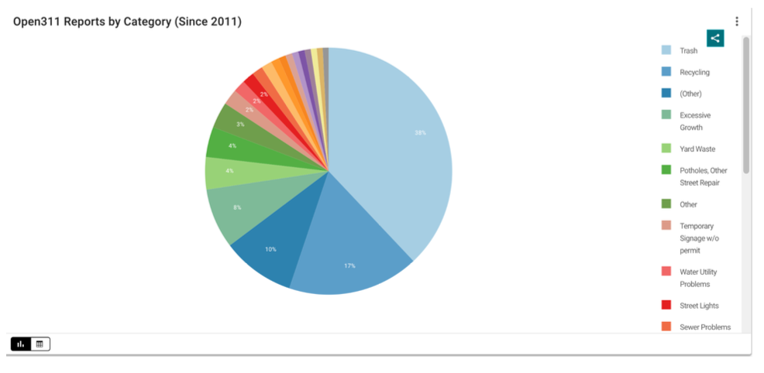

**Figure:** Pie Chart representing categories in complaints reported

From the above graph, we can understand that, since 2011, the Open311 reports broken down by category have been a useful resource for learning about local issues. "Trash" is the most common category, making up 38% of all requests, followed by "Recycling" at 17%. With 8% and 4% of the requests, respectively, infrastructure problems, including "Excessive Growth" and "Potholes, Other Street Repair," are also important. This information emphasizes the value of community trash management, infrastructure upkeep, and environmental awareness. By successfully prioritizing and addressing these issues, local authorities can improve people's quality of life and the efficiency of the city's services.

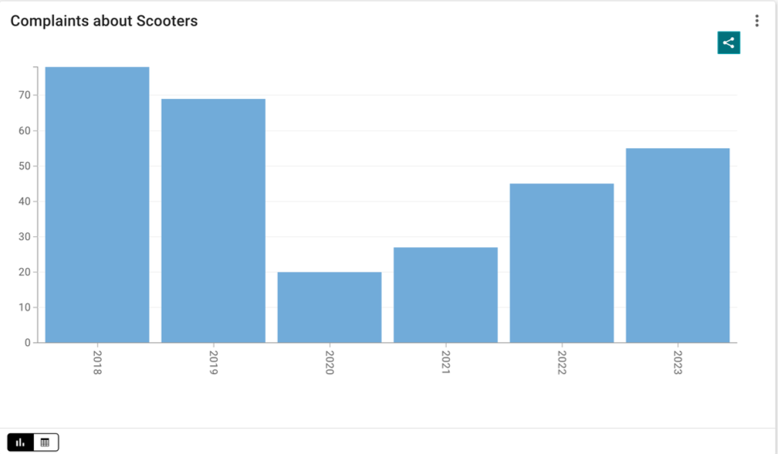

**Figure:** Complaints related to scooters in given data

The above graph depicts the complaints related to scooters, which have shown varying trends over the years, as indicated by the data provided. 2018 there were 78 scooter-related complaints, which decreased to 69 in 2019. However, there was a more substantial decline in 2020, with only 20 complaints, likely influenced by the COVID-19 pandemic. Interestingly, as the situation improved, the number of scooter complaints increased to 27 in 2021, and this trend continued into 2022 with 45 complaints. In 2023, the complaints rose to 55, suggesting a resurgence of scooter concerns. These fluctuations in complaints could be attributed to various factors, including changes in scooter regulations, usage patterns, or public perception. It's crucial for local authorities to closely monitor these trends to address any emerging issues and ensure the safe and responsible use of scooters in the community.

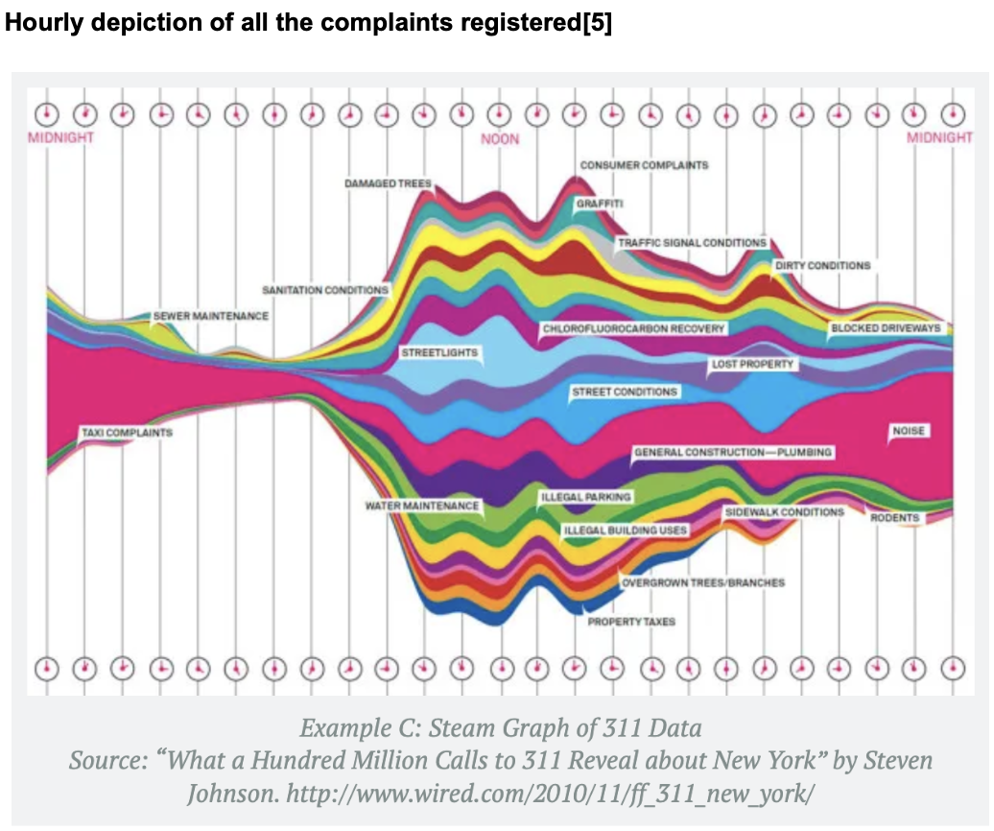

**Figure:** Hourly depiction of all the complaints registered

The creator of this visualization has provided an insightful glimpse into New York City's inner workings by aggregating 311 complaints not only by type but also by the hour. The data reveals that noise is a predominant source of annoyance for New Yorkers, primarily during the evening and early morning hours. In contrast, issues like poor street conditions and illegal building use tend to be reported during the daytime. Taxi-related complaints align with taxi usage patterns, with a noticeable drop during late evening and early morning hours. Furthermore, given New York's reputation for housing issues, the author, drawing from personal experiences with difficult landlords, emphasizes the importance of a complaint algorithm for tenants. While an hourly visualization offers valuable insights, a monthly perspective could provide a unique view of New Yorkers' challenges in their apartments throughout the season.

**Critical Analysis of Existing Methodologies**

While these studies represent significant strides in urban data analysis, they exhibit limitations that our project aims to address:

* Static Visualization Limitations: Many existing studies rely heavily on static visualizations. While informative, these visualizations lack the interactivity necessary for a more engaged and exploratory analysis. Static charts and maps provide a fixed perspective, which can obscure underlying patterns and trends that emerge over time or under different conditions.
* Narrow Focus on Data Visualization: While proficient in data visualization, several studies need to delve deeper into the analytical potential of the data. Visualization is often an endpoint rather than a means to an end, leading to a superficial understanding of the underlying issues.

**Bridging the Gap**

By combining these methods, our project aims to bridge the gap between static and dynamic analysis, offering a more holistic view of civic engagement. The interactive visualizations developed from our notebook allow users to explore data across multiple dimensions, fostering a deeper understanding of the interplay between different civic issues, their geographical locations, and their temporal patterns.

**Objectives / Contribution:**

Our "Visualizing Civic Engagement - City of Bloomington" project is driven by a compelling motivation to understand and enhance the dialog between Bloomington's residents and its local government. This motivation leads us to several key questions that guide our research and analysis. By answering these questions, we aim to provide meaningful insights into civic engagement within the city, contributing to more effective urban governance and an engaged community.

Primary Objectives**:**  Our primary objectives are to investigate and visualize various aspects of the Open311 civic data, including:

* Service Request Patterns Over Time:

How have the types and frequencies of service requests in Bloomington changed over the years? Are there discernible patterns or trends in civic issues reported by residents?

* Agency Response and Efficiency:

Which city agencies are most responsive to service requests? How do their response times and resolution rates vary?

* Geographic Distribution of Civic Engagement:

Are there specific areas in Bloomington that report more service requests? What does the spatial distribution of these requests reveal about the different neighborhoods in the city?

**Contributions of the Study**

The outcomes of this study are expected to contribute to a range of areas, including:

* Urban Planning and Policy Making:

Providing data-driven insights to assist city planners and policymakers make informed decisions about resource allocation and urban development strategies.

* Community Awareness and Engagement:

Enhancing the understanding of civic engagement among Bloomington residents, encouraging more active participation in civic matters.

* Advancement in Civic Data Analysis:

Contributing to the field of urban studies by showcasing the potential of civic data in understanding and improving urban life, serving as a model for other cities.

**Process:**

**Data Collection:** Open311 Dataset

Our primary data source is the Open311 dataset the City of Bloomington provided. This dataset encompasses a comprehensive range of resident civic service requests, along with details about each request, such as its type, submission date, status, resolution time, and the responsible city agency. The dataset covers a substantial period, offering a rich historical perspective on civic engagement trends in Bloomington.

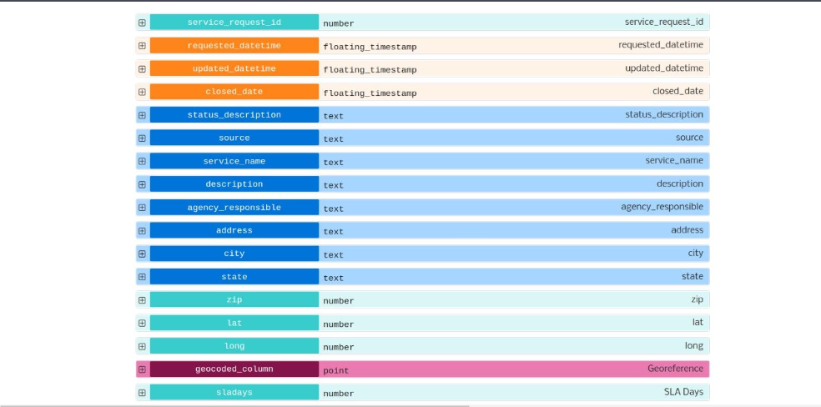

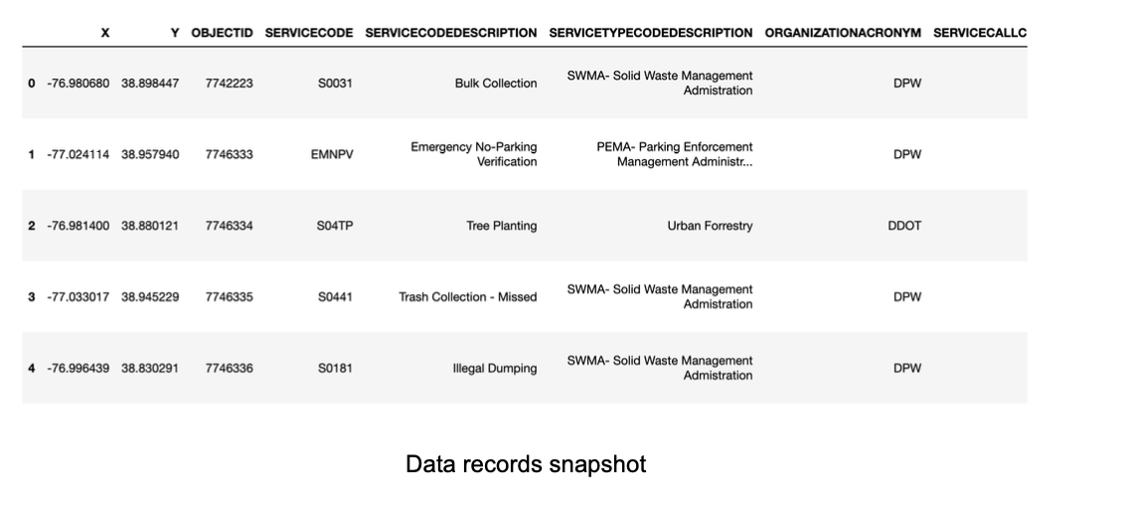

**Data Features**

**Key features of the data include:**

Service Request ID: Unique identifier for each service request.

Request Type: Category of the service request, e.g., infrastructure issues environmental concerns.

Submission and Resolution Dates: Time stamps indicating when a request was submitted and resolved.

Status: status of the request (e.g., open, closed).

Responsible Agency: City department or agency responsible for addressing the request.

Geolocation Data: Geographic coordinates indicating the location of the service request.

**Data Pre-Processing**

The initial step in our analysis involved extensive data cleaning. This process included handling missing values, correcting data inconsistencies, and filtering out irrelevant or erroneous entries. We also standardized the formats of dates and categorical variables for consistency. We transformed the dataset to suit our analysis needs. This involved categorizing service requests into broader themes for a more general analysis and creating time-based variables for temporal trend analysis.

After pre-processing, the details of the dataset are as follows:

**Int64Index: 26353 entries, 77 to 111177**

**Data columns (total of 17 columns):**

**# Column Non-Null Count Dtype**

**--- ------ -------------- -----**

**0 service_request_id 26353 non-null int64**

**1 requested_datetime 26353 non-null datetime64[ns]**

**2 updated_datetime 26353 non-null object**

**3 closed_date 25977 non-null object**

**4 status_description 26353 non-null object**

**5 source 21041 non-null object**

**6 service_name 26353 non-null object**

**7 description 22859 non-null object**

**8 agency_responsible 26353 non-null object**

**9 address 25963 non-null object**

**10 zip 26353 non-null object**

**11 lat 26353 non-null float64**

**12 long 26353 non-null float64**

**13 Georeference 26353 non-null object**

**14 SLA Days 9445 non-null float64**

**15 response_time 25977 non-null float64**

**16 year 26353 non-null int64**

**types: datetime64[ns](1), float64(4), int64(2), object(10)**

**memory usage: 3.6+ MB**

**Methodology:**

**Geospatial Analysis:**

Using GIS tools and Python libraries like Geopandas, we conducted a geospatial analysis to map the distribution of service requests across Bloomington. This analysis helped identify areas with higher frequencies of specific requests, providing insights into the geographic concentration of civic issues.

**Interactive Visualization:**

Leveraging Python's Plotly library, we created interactive dashboards allowing users to dynamically explore civic data. These dashboards enable users to filter data by various parameters, such as time, request type, and location, offering a more personalized and detailed data exploration.

**Visualization:** Top 10 Most Requested Services Each Year

**Bar Chart:**

Our initial approach to visualizing the **"Top 10 Most Requested Services Each Year"** began with bar charts, a common choice for depicting quantitative data. We prepared the dataset by grouping it by year and service name and counting the occurrences for each service. Bar charts effectively showcased the volume of service requests per year. However, we encountered challenges in comparative analysis. While each bar chart depicted data for a single year, drawing comparisons across multiple years proved less intuitive. This limitation became particularly evident when dealing with numerous service types, as the charts quickly became cluttered. The format restricted our ability to track the progression of service demand over multiple years, leading us to consider other visualization methods.

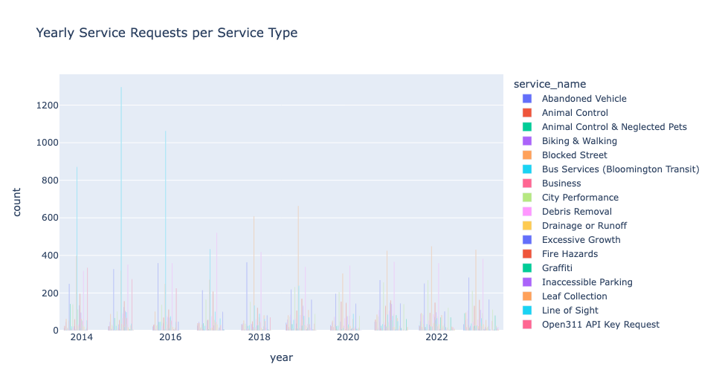

**Line Graph:**

As an alternative, we explored the use of line graphs to capture trends over time. We restructured the data to fit a time series format suitable for line representation. Line graphs offered a clear view of trends for individual service types across years. However, representing multiple categorical service types on the same graph introduced its own challenges. Lines often overlapped, creating a visually complex and confusing chart, especially when comparing the top 10 services simultaneously. This led to difficulties in effectively discerning individual trends and made comparative analysis across several services challenging.

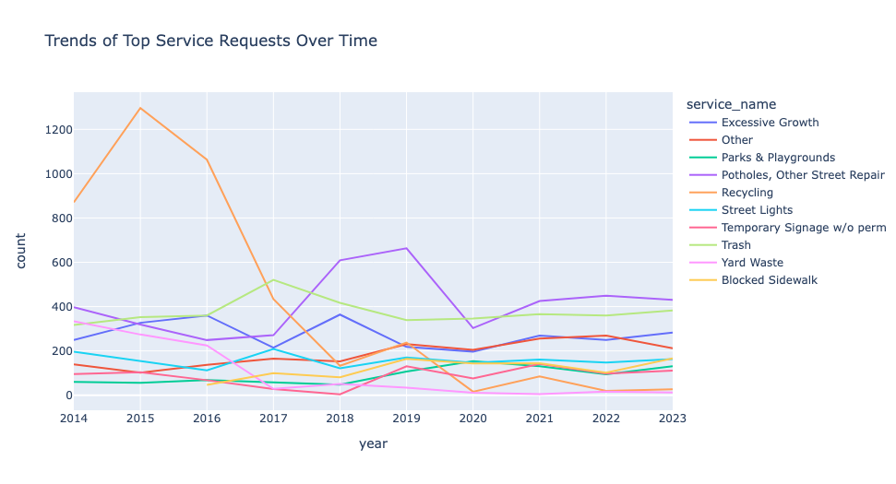

These initial visualization attempts using bar charts and line graphs provided crucial insights. They highlighted the challenges in representing complex, multi-dimensional data and the need for a visualization method that could compactly and hierarchically display the data. This exploration and the lessons learned from it were instrumental in guiding us toward selecting a treemap for our final visualization. The **treemap** addressed the shortcomings of the previous methods by providing a clear, comparative view of service request volumes across multiple years and service types, all within a single, cohesive visual space.

**Tree Map (Final Version):**

We transformed the data to count the occurrences of each service type per year. The challenge was to ensure accurate aggregation and appropriate handling of the categorical nature of service types. We selected the 'Viridis' color scale for its accessibility and visually appealing gradient, enhancing the interpretability of the data.

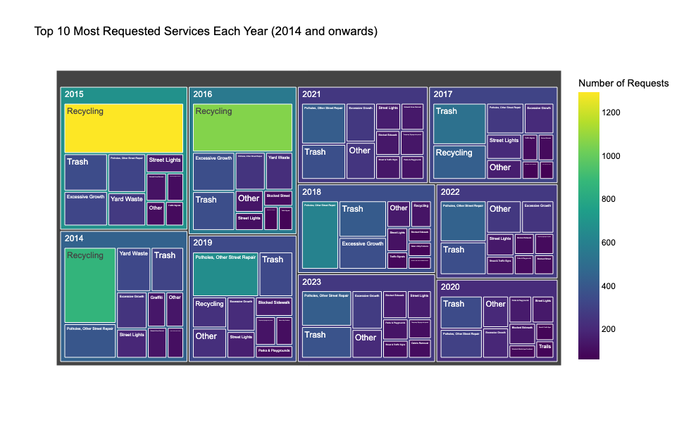

**Visualization:** Top 5 Most Active Agencies Each Year

**Static bar chart**:

Our initial visualization strategy for showcasing the activity of different agencies began with static bar charts. We grouped the data by year and agency, tallying the number of service requests to create a dataset that lent itself well to a bar chart format. While static bar charts effectively displayed the number of requests handled by each agency in a given year, they fell short of comparing across multiple years. This became a significant limitation, especially when observing trends or shifts in agency activity over time. The clarity of the data presentation suffered due to the inability of static bar charts to encapsulate the dynamic nature of the dataset effectively.

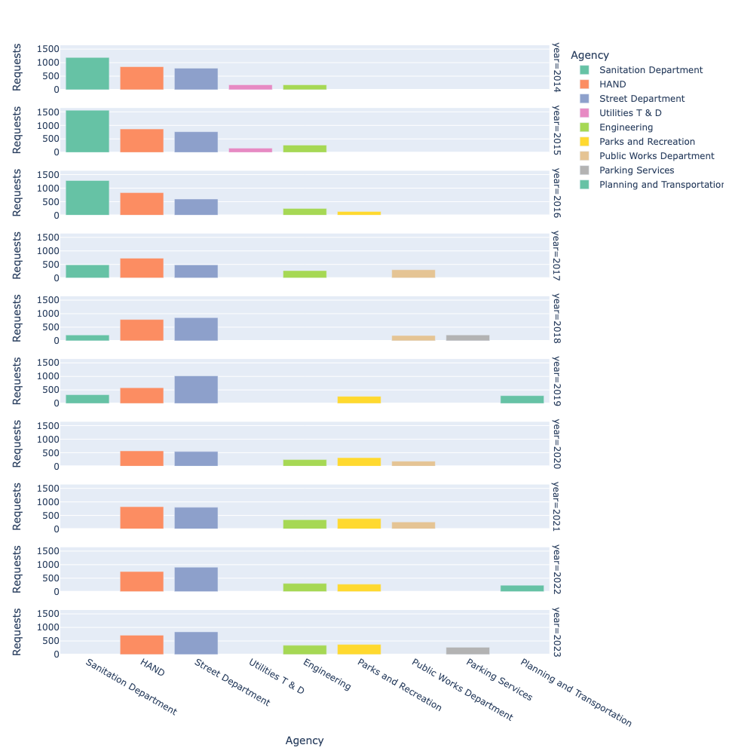

**Pie Chart**:

Seeking an alternative, we turned to pie charts, aiming to represent the proportion of service requests handled by each agency within a single year. Although pie charts offered a visually appealing way to depict the distribution of service requests among agencies, they could have been more limited in their ability to portray changes over time. The static nature of pie charts did not allow for an easy comparison of agency activities from year to year, making it challenging to identify trends or evolving patterns in the data.

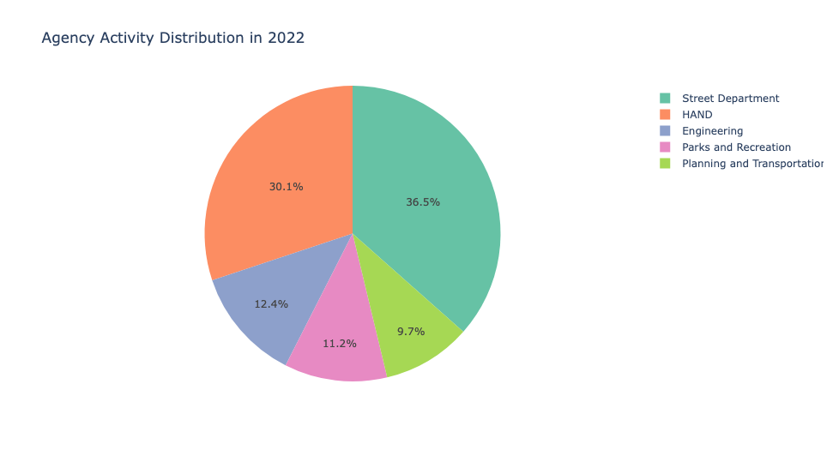

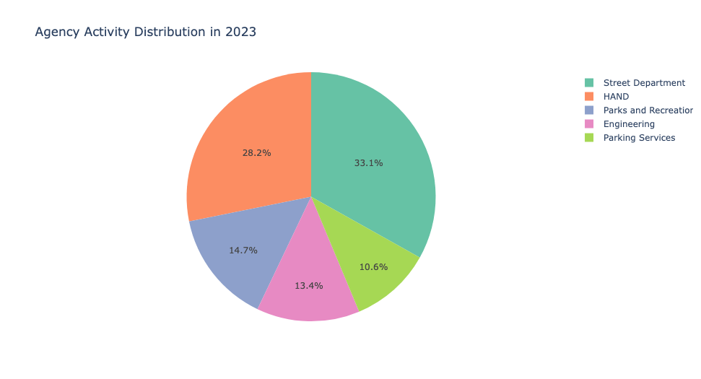

The insights gained from experimenting with static bar charts and pie charts led us to consider more dynamic forms of data visualization. The **animated bar chart** emerged as a solution, overcoming the limitations of the previous methods. It represented the volume of service requests handled by each agency. It added a dimension, allowing viewers to observe changes in agency activities over the years. This dynamic approach to data visualization proved to be more effective in conveying the evolving landscape of agency responsibilities and engagements in civic issues.

**Animated Bar Chart (Final Version):**

We chose the animated bar chart for its ability to depict changes over time dynamically, offering an engaging and clear visualization of how different agencies' activities evolve annually. The 'Set2' palette was used for its distinct colors, making each agency's bar easily identifiable.

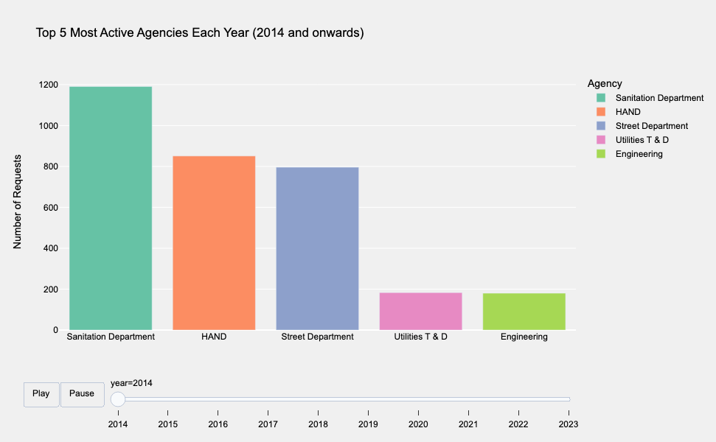

**Visualization:** Distribution of Requests for Top 20 Most Reported Service Types Over Months

**Heatmap:**

In our initial attempt to visualize the monthly distribution of service requests, we explored the use of heat maps. We prepared our dataset by creating a matrix-like structure where each cell represented the count of requests for a specific service type in a month. However, while the heatmap effectively showed variations in request densities, it needed to convey the exact count of requests. Differentiating between service types with similar request volumes was challenging, as it relied on subtle color gradations. This limitation made it difficult to accurately interpret the exact request volumes for each service type.

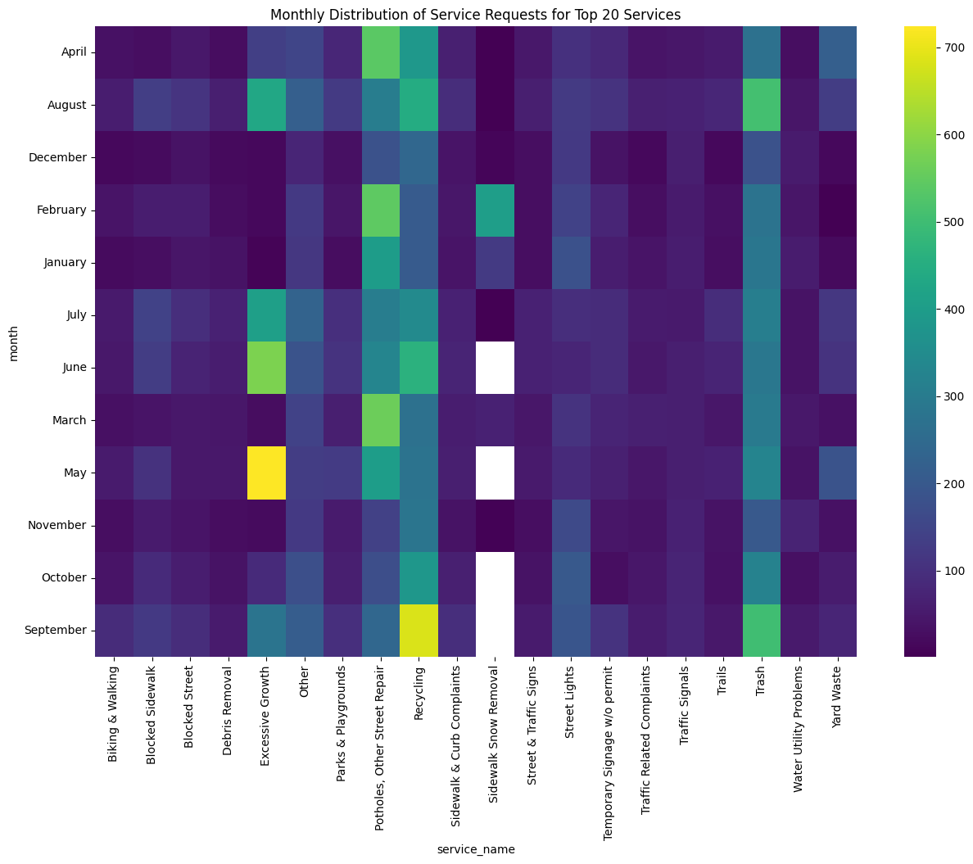

**Stacked Bar Charts:**

We turned to stacked bar charts as an alternative. Each bar in this visualization represents a month, segmented by different service types. This approach aimed to provide a more precise breakdown of monthly service request distributions. Despite organizing the data to create layered segments within each bar, we encountered readability issues. The complexity of stacking 20 service types within a single bar led to a cluttered visual. Individual service types became difficult to distinguish, and comparing specific services across different months could have been more intuitive due to the overlapping segments and the need to track the same color across all bars.

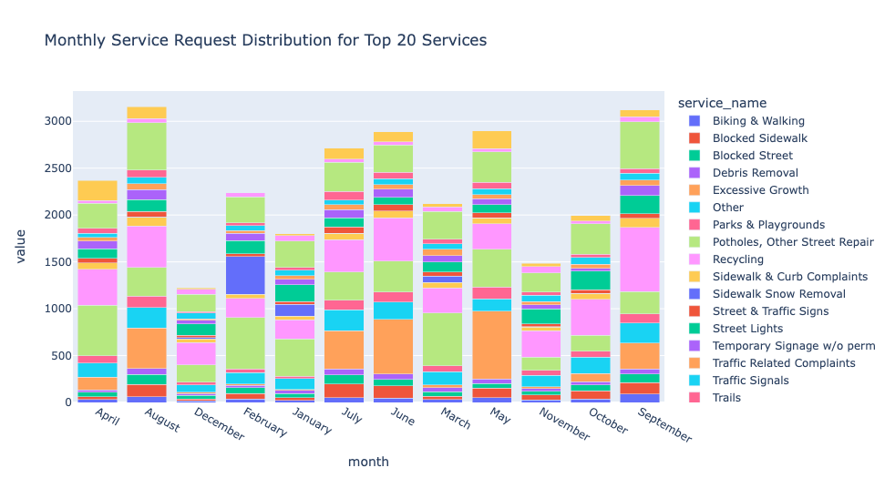

These challenges with heatmaps and stacked bar charts led us to consider the **scatter plot**. This format provided a detailed view of each service type's request volume across different months in a more interpretable and accessible manner. It effectively captured the relationship between service types, request volumes, and seasonality patterns.

**Scatter Plot (Final Version):**

For our analysis of the monthly distribution of the top 20 service requests, we chose a scatter plot for its explicit depiction of individual data points, highlighting the relationship between service types and months. We grouped the data by month and service type, counting each occurrence to fit the scatter plot format. We utilized a color-coding scheme to differentiate each month, significantly enhancing the plot's clarity and interpretability. This approach efficiently bridged the gap between complex data and accessible visualization, making the scatter plot an ideal choice for our analysis.

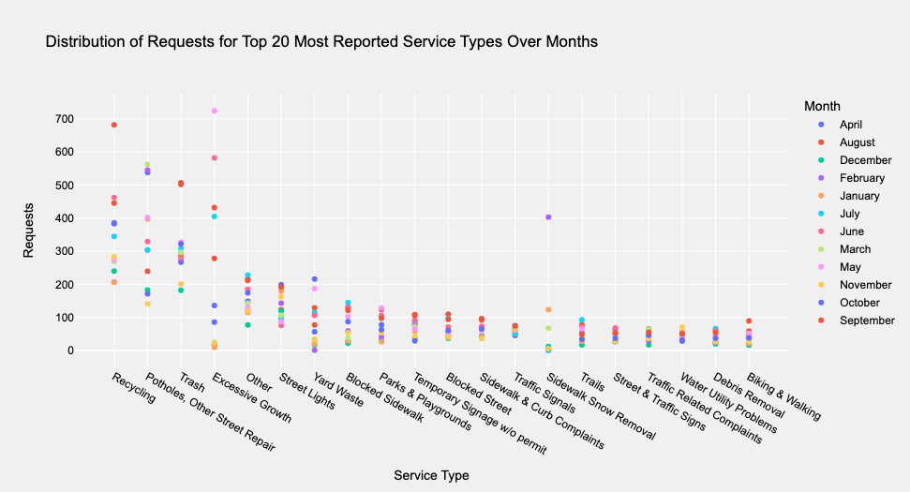

**Visualization:** Understanding the locations of the requests made

Understanding location data is one of the most essential stages of analysis we intended on doing as it would reveal easy-to-comprehend information. With the help of latitude and longitude columns from the dataset, we tried various plots to make compelling visualizations.

**Location data - version A**

The map data is generated using the geographical data from the dataset. Using the Scattergeo object made available by the Python package Plotly. The resultant map is centered around the longitude and latitude of Bloomington, Indiana. The map allows users to zoom in and out, but that particular feature could be more effective in our case, which kicked off our search for better methods.

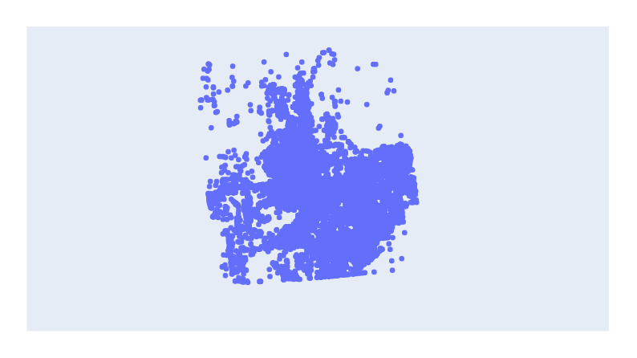

**Figure**: Location map using Plotly

**Location data - version B**

With the help of Folium, a more interactive and user-friendly map with all the locations was obtained, allowing users to zoom in and out and providing precise geographical and neighborhood data. This map is also designed to center around the location of the city of Bloomington, Indiana. However, we were looking for a map visualization that simplifies the location data further, making it easy for the general audience to grab the information. It is more than just looking at a set of cluttered red dots.

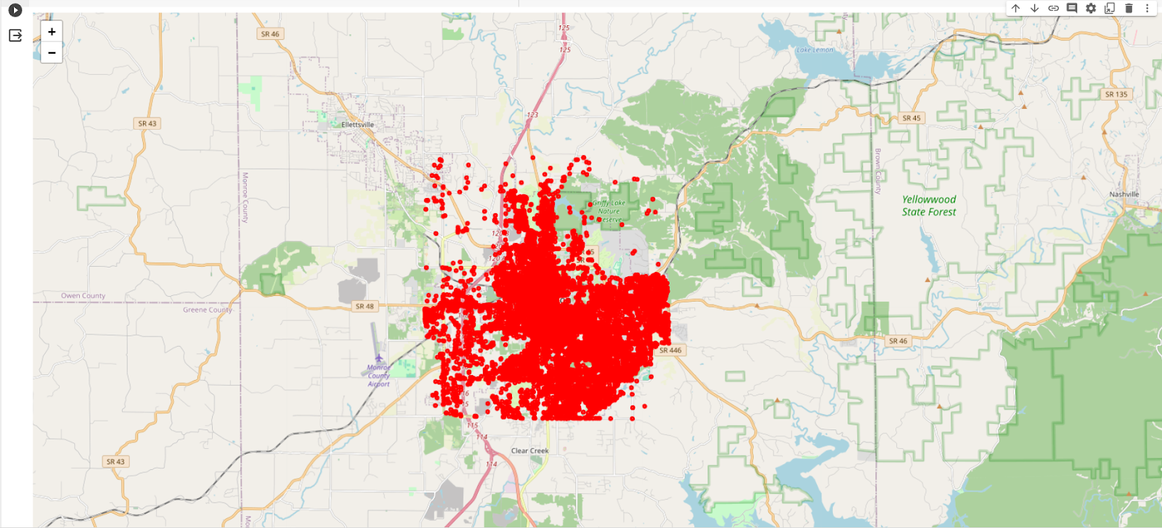

**Figure**: Location map using Folium

**Clustered location data (Final version)**

Using the MarkerCluster object from the Folium package, we could generate clustered data that had not only dynamically changing clusters with the display of the number of points under that cluster but also color coding that denoted the density of the points. This map is extremely helpful in understanding the contribution of requests from a particular street, neighborhood, area, and any appropriate zoom level that the user is willing to look at.

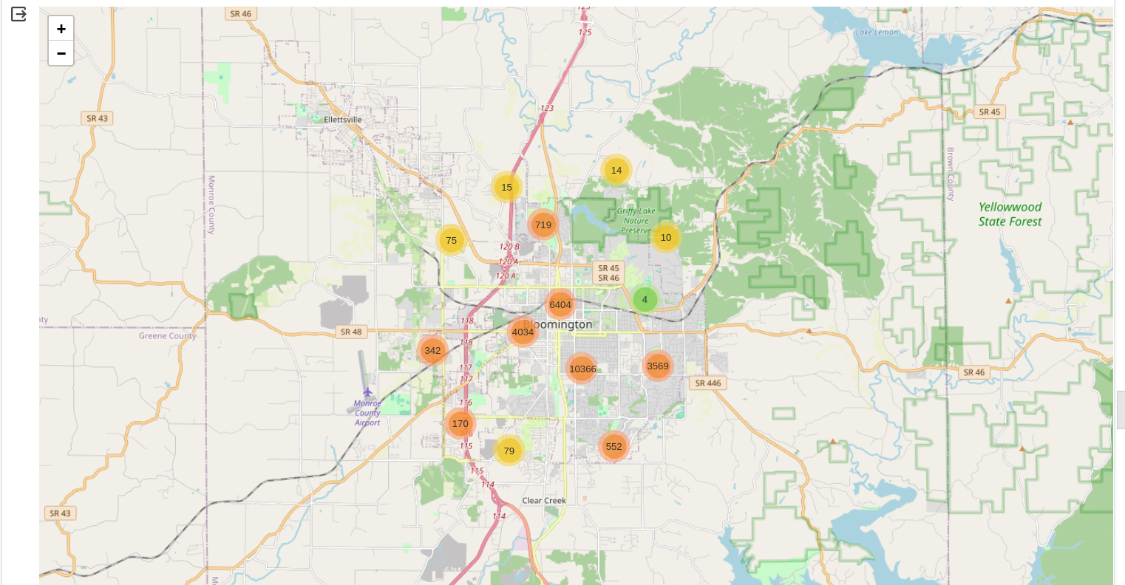

**Figure**: Clustered location map using Plotly

**Visualization:** Distribution of service requests by ZIP Code

We also wanted to visualize the distribution of the service requests by zip code. This allows a more sophisticated view of the data. As zip code is a popular and well-recognized geographical division, it makes conveying the intended message more manageable and more helpful.

**Bar Graph**

By creating a vertical bar graph, we wanted to visualize the number of service requests from each zip code. This allows for an easier comparison of areas with higher and lower service demand. Although simple, we needed a better way to visualize this data.

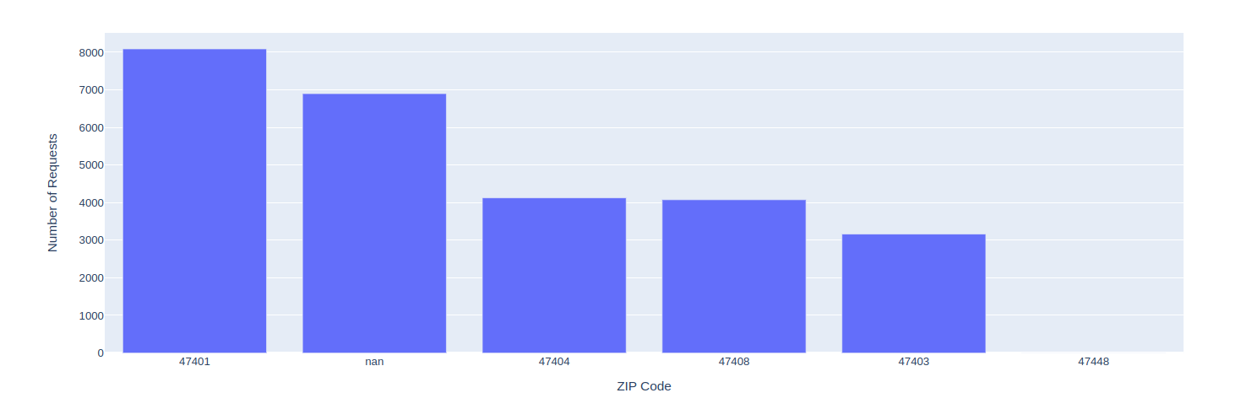

**Figure**: Barchart for service requests distribution on at Zip Code level

**Choropleth (Final version)**

With the help of Choropleth from Plotly, we could visualize the concentrations of each zip code's service requests and provide a spatial distribution focused on the city of Bloomington, Indiana. With color coding, where a darker shade signifies a higher number of requests, the final output was more successful in conveying our intention.

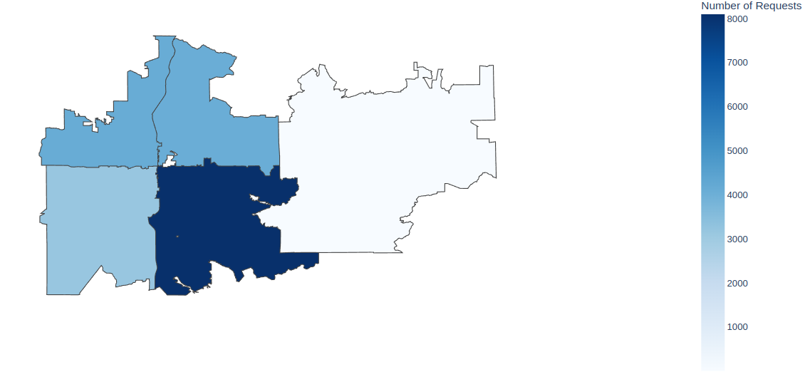

**Figure**: Choropleth for service requests distribution based on Zip Codes of Bloomington, IN

**Visualization:** Locations of agency-wise service requests

**Grid plot**

We wanted to show how services requested by each agency vary in geographical location. For this, the initial idea was to create a grid plot where each subplot maps locations of service requests made for the respective agency on the geographical map of the city of Bloomington, Indiana.

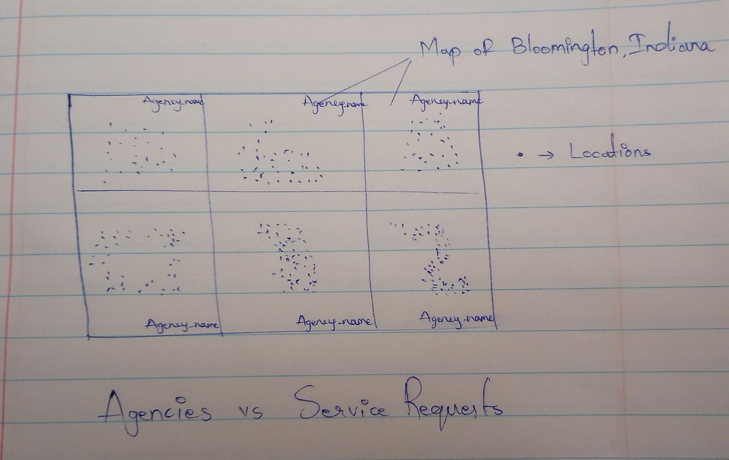

**Figure:** Sketch showing the intended plot for visualizing agencies and their service requests

But, as we tried different ways to do it, most progress was made with the help of plotly scattergeo. However, the intended format was not achieved due to the incompatibility of scattergeo with the ‘xy’ subplot, we were able to visualize the plot where each subplot is in a new line. This needed a change of approach and we explored other better ways to visualize.

**Open issues dashboard (Final version)**

Dash, a Python package, allows us to design simple yet effective dashboards. Leveraging Dash, we were able to design a dashboard that visualizes the locations of service requests intended for each agency but also labels them with the name and timestamp. The final version also included the count of the service requests made for each agency. For the sake of better utility, we fixed our visualizations to only currently open issues, which provided a good perspective on agencies' responsiveness.

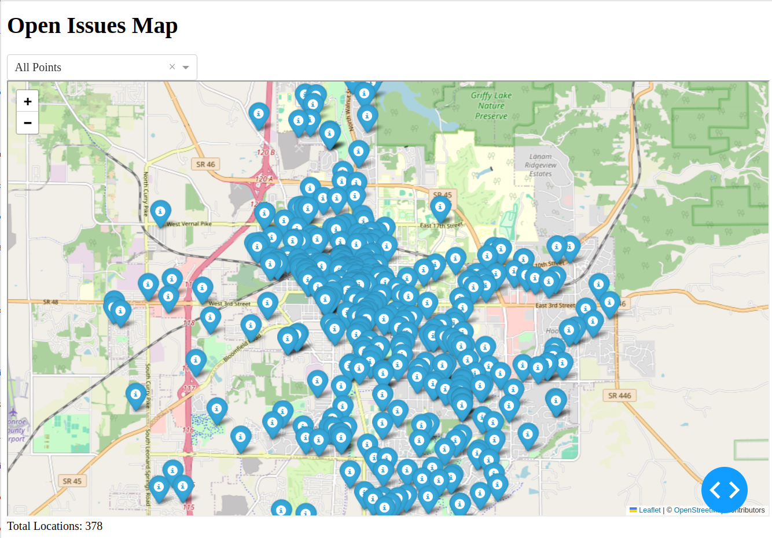

**Figure:** Open issues map visualizing all the service requests that are currently being resolved

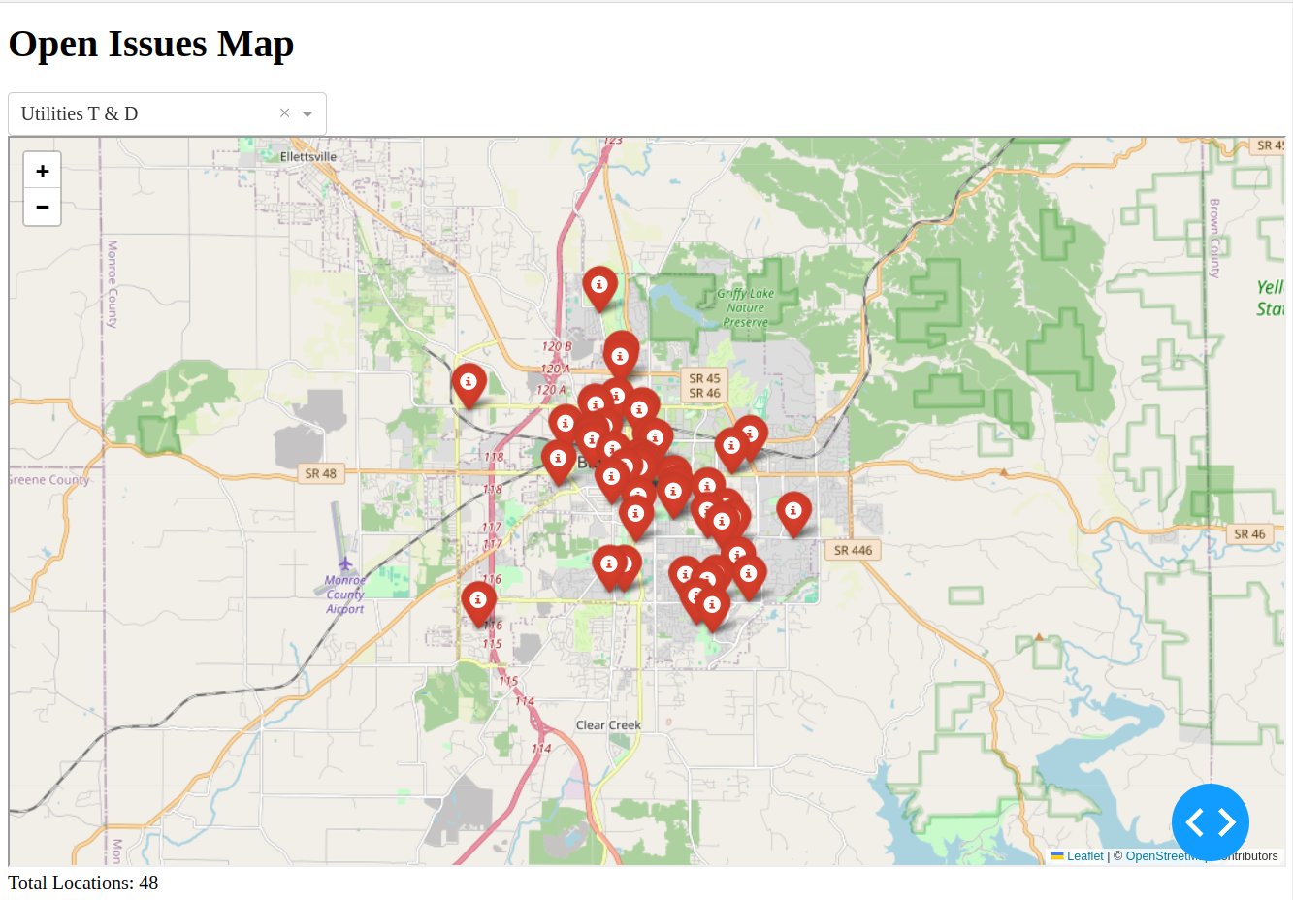

**Figure:** Open issues map visualizing all the service requests addressed to the Department of Utilities and T&D that are currently being resolved

### 

### 

### 

### 

### 

### 

### 

### 

### 

### 

### 

### 

### 

### 

### 

### 

### **Results and Insights:**

**1. Top 10 Most Requested Services Each Year**

**Interpretation**:

The treemap vividly illustrates the distribution of service requests. More significant and darker blocks highlight services with higher request volumes, making it easy to spot the most demanded services each year.

**Key Insights**:

1. **Dominant Services**: Services like 'Recycling' and 'Trash' consistently appear as larger blocks, indicating their dominance in civic concerns over the years.
2. **Yearly Variations**: The visualization effectively captures the fluctuation in service demands. For instance, some years show a higher demand for 'Yard Waste' services.
3. **Emerging Trends**: The presence of services such as 'Excessive Growth' in specific years points to emerging community issues that require attention.

**2. Top 5 Most Active Agencies Each Year**



**Interpretation**:

The animated bar chart illustrates the fluctuating activity levels among the top agencies from 2014 to 2023.

**Key Insights**:

1. **Agency Activity Trends**: Agencies like the Sanitation Department and HAND consistently appeared among the top, indicating their significant role in handling service requests.
2. **Year-over-Year Comparison**: The animation highlighted which agencies were most active each year, showing how their roles and responsibilities shifted over time.

**3. Distribution of Requests for Top 20 Most Reported Service Types Over Months**



**Interpretation**:

The scatter plot illustrates how service requests for the top 20 types are distributed over different months, with each dot representing the volume of requests for a specific service in a given month.

**Key Insights**:

1. **Seasonal Patterns**: The plot reveals clear seasonal trends, such as increased requests for **Yard Waste** during fall and **Snow Removal** during winter.
2. **Consistent Demand Services**: Services like **Potholes** and **Trash** show consistent yearly demand, with noticeable peaks in certain months.

**4. Understanding the locations of the requests made**

**Interpretation:**

In Folium, the **MarkerCluster()** object is utilized to manage and display markers on a map efficiently. This is particularly useful when working with latitude and longitude columns from Open 311 data, allowing the creation of visually clean and interactive maps with clustered markers based on geographic coordinates.



**Figure**: Clustered location map using Plotly

**Key Insights:**

Clustering gave us a sense of where most issues are situated, and zooming in and out provided us with an understanding of what areas, in general, contribute to most requests.

**5. Distribution of service requests by ZIP Code**

**Interpretation:**

The Plotly **Choropleth** Python package visualizes geographic data, focusing on Open311 data's "zip" columns.



**Figure**: Choropleth for service requests distribution based on Zip Codes of Bloomington, IN

**Key Insights:**

Distributing the requests by zip code with the help of choropleth showed us how most of the issues are from certain zones, which explains the population density of those areas.

**6. Locations of agency-wise service requests**

**Interpretation:**

Dash, a Python package, is employed to create dynamic and interactive web-based visualizations using data from Open 311. The focus is on the "lat," "long," and "agency_responsible" columns, specifically filtering data where the "status_description" is set to 'open'.



**Figure (a):** Open issues map, visualizing all the service requests that are currently being resolved



**Figure (b):** Open issues map, visualizing all the service requests addressed to the Department of Utilities and T&D currently being resolved.

**Key Insights:**

The visualization of open issues of individual agencies, along with their count, gave us a further understanding of what needed to be improved in the location mapping plot. This dashboard can allow citizens to know about nearby requests and is an excellent foundation for further developments.

**Conclusion**

Through this project, "Visualizing Civic Engagement - City of Bloomington," we have acquired substantial insights into data-driven urban analysis. Our venture into creating innovative and interactive visualizations honed our technical skills and deepened our understanding of the intricacies of civic engagement in urban settings. Among the most enlightening insights were the variations in civic issue reporting across different neighborhoods of Bloomington and the responsiveness of various city agencies to these issues. This project highlighted the significant role of geospatial and temporal data in understanding urban dynamics. We observed patterns that underscored the need for targeted urban planning and resource allocation in specific areas of Bloomington, thereby promoting a more efficient and responsive urban governance model.

Looking ahead, we are inspired to further advance our research. One key area of interest is integrating more granular geospatial data, including latitude and longitude coordinates, to map civic engagement patterns down to specific streets and locales within Bloomington. Such enhanced geospatial analysis could offer even more precise urban planning and community development insights.

Additionally, we envision the incorporation of real-time data analytics. Developing an API that fetches and updates civic data annually or in real-time would be a significant stride forward. This would ensure that our visualizations and analyses remain current and allow for more dynamic and predictive urban management strategies.

Another intriguing prospect is examining the relationship between civic engagement patterns and broader socioeconomic indicators. By correlating civic data with demographic and economic factors, we aim to uncover deeper, systemic insights into the urban fabric of Bloomington. This multidimensional approach could provide a more holistic view of the city's civic health and guide more nuanced policy interventions.

In conclusion, "Visualizing Civic Engagement - City of Bloomington" has been a journey of discovery and innovation. It has laid the foundation for more advanced, real-time, and comprehensive urban data analysis, potentially impacting urban planning, policymaking, and community engagement in Bloomington and beyond.

**References:**

1. <https://www.open311.org/>
2. https://www.mysociety.org/2013/01/10/open311-introduced/
3. <https://www.govloop.com/community/blog/the-future-of-government-open-311-best-practices/>
4. <https://bsquarebulletin.com/2019/07/20/chalking-one-up-for-poison-ivy-reports/>
5. <https://studentwork.prattsi.org/infovis/visualization/tenants-call-the-311-visualizing-nyc-housing-complaints/>
6. https://medium.com/@starsinmypockets/exploring-open311-data-5a4993db8d43
7. <https://www.kaggle.com/code/ambarish/austin-nyc-311-calls-eda-maps-timeseries>
8. <https://www.kaggle.com/code/rajnaruka0698/311-calls-pittsburgh-analysis>
9. <https://hunterurbanreview.commons.gc.cuny.edu/the-value-of-311-data/>
10. <https://github.com/ikp-ogbeide/nyc-311-data-analysis/blob/master/README.md>
11. <https://data.edmonton.ca/Indicators/311-Explorer/ukww-xkmj/data>
12. <https://plotly.github.io/plotly.py-docs/generated/plotly.graph_objects.Scattergeo.html>
13. <https://github.com/Leaflet/Leaflet.markercluster>
14. <https://cloud.google.com/blog/products/maps-platform/how-cluster-map-markers>